"But what a scene did we witness! The Majesty of the People had disappeared, and a rabble, a mob, of boys, negros [sic], women, children, scrambling fighting, romping. What a pity what a pity! No arrangements had been made no police officers placed on duty and the whole house had been inundated by the rabble mob. We came too late.
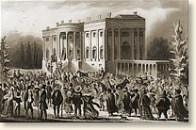
The crowd storms the
White House
The President, after having been literally nearly pressed to death and almost suffocated and torn to pieces by the people in their eagerness to shake hands with Old Hickory, had retreated through the back way or south front and had escaped to his lodgings at Gadsby's.

