Elements of Synthesis Writing: The Wordy Shipmates, Sarah Vowel

1. Puritans believe they are chosen by God & know His path; therefore their mission is to ensure others follow. (Topic Sentence for Puritan POV)

“. . . the country I live in is haunted by the Puritans’ vision of themselves as God’s chosen people, as a beacon of righteousness that all others are to admire. The most obvious and influential example of that mind-set is John Winthrop’s sermon ‘A Model of Christian Charity,’ in which he calls on New England to be ‘a city upon a hill.’ The most ironic and entertaining example of that mind-set is the Massachusetts Bay Colony’s official seal. The seal, which the Winthrop fleet brought with them from England, pictures an Indian in a loincloth holding a bow in one hand and an arrow in the other. Words are coming out of his mouth. The Indian says, ‘Come over and help us.’” p. 24 (Example of excerpt as evidence with analysis)

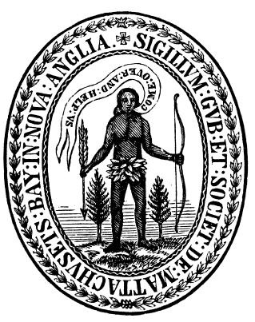
(Example of visual source as evidence)

“The worldview behind that motto—we’re here to help you, whether you want our help or not—is the Massachusetts Puritans.” p. 25 (Example of analysis)

2. People from the far corners of the globe often describe a similar vision of the American Dream, yet there are conflicting experiences for those who have reached out to grasp it. (Example of Topic Sentence)

“”Christian Charity” begins: ‘God Almighty in His most holy and wise providence, hath so disposed of the condition of mankind, as in all times some must be rich, some poor, some high and eminent in power and dignity; others mean and in subjection.’” P. 37 (Example of excerpt as evidence)

“Compare his [Winthrop] hard, cold fact that ‘some must be rich, some poor’ to the shocking second sentence of the Declaration of Independence, written 146 years later: ‘We hold these truths to be self-evident, that all men are created equal, that they are endowed by their Creator with certain inalienable Rights, that among these are Life, Liberty, and the pursuit of Happiness.” P. 37 (Example of author clustering evidence)

“Winthrop is saying the opposite-that God created all men unequal.” P. 37 (Example of author’s analysis of above cluster of evidence)

“To him [Winthrop], the city on the hill was also something else, something worse—a warning. If he and his shipmates reneged on their covenant with God, the city on the hill would be a lighthouse of doom beckoning the wrath of God to Boston Harbor.” P.58 (Example of author’s analysis)

“This contradiction—between humility before God and the egomania unleashed by being chose by God—is true of both Winthrop and the colony of Massachusetts itself.” P. 39 (Example of author’s analysis and closing/clincher statement for synthesis)

James Baldwin, a civil rights activist, once remarked, “American history is longer, larger, more various, more beautiful, and more terrible than anything anyone has ever said about it.” Throughout the American story, individuals and groups have sung the praises of Jefferson’s claim of inalienable rights and equality for all while others found those promises to be hard won, or even unattainable. (Evidence and analysis I bring that is not in the reading--outside knowledge)

And so this paradoxical foundation is laid and the tension between these contrasting views plays out over and over again throughout the American story. (Ms Lawrence, a student of history’s example of a closing/clincher statement for synthesis.)

